GOOGLE CLOUD LAB

1.Execute a Python Program in Google Cloud Shell
Aim: Run a Python application using a cloud-based environment.
GOOGLE CLOUD HOME PAGE
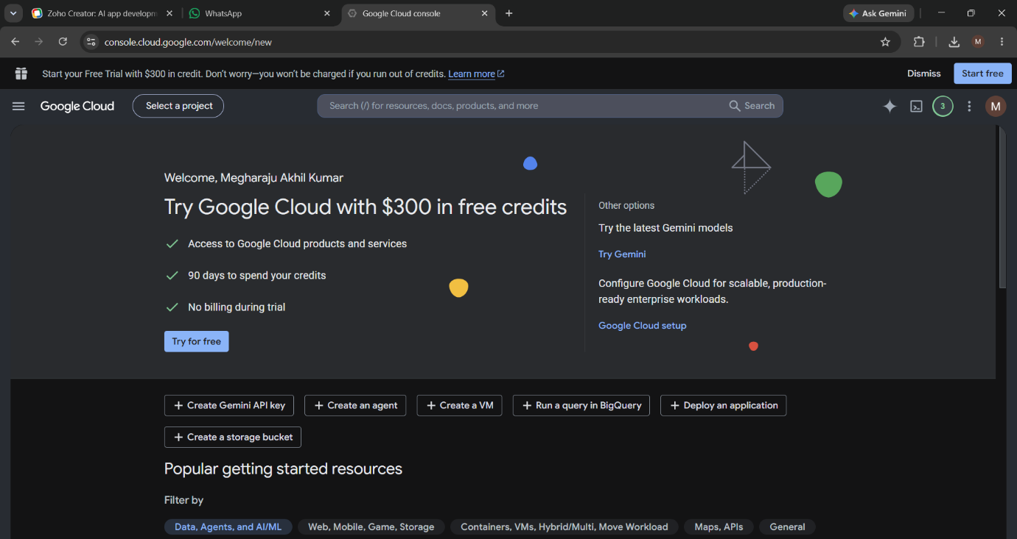
AUTHORIZE CLOUD SHELL
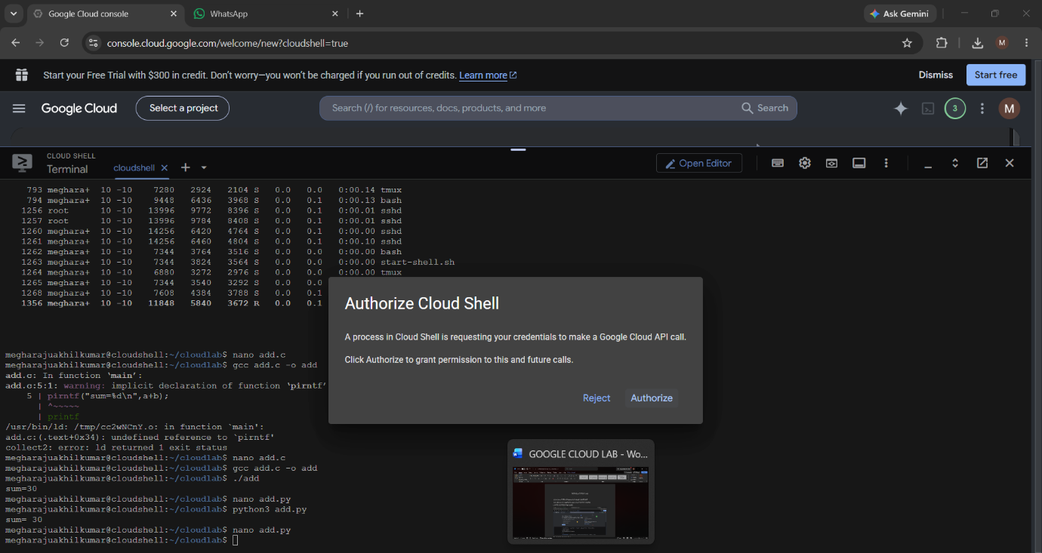

NANO HELLO.PY
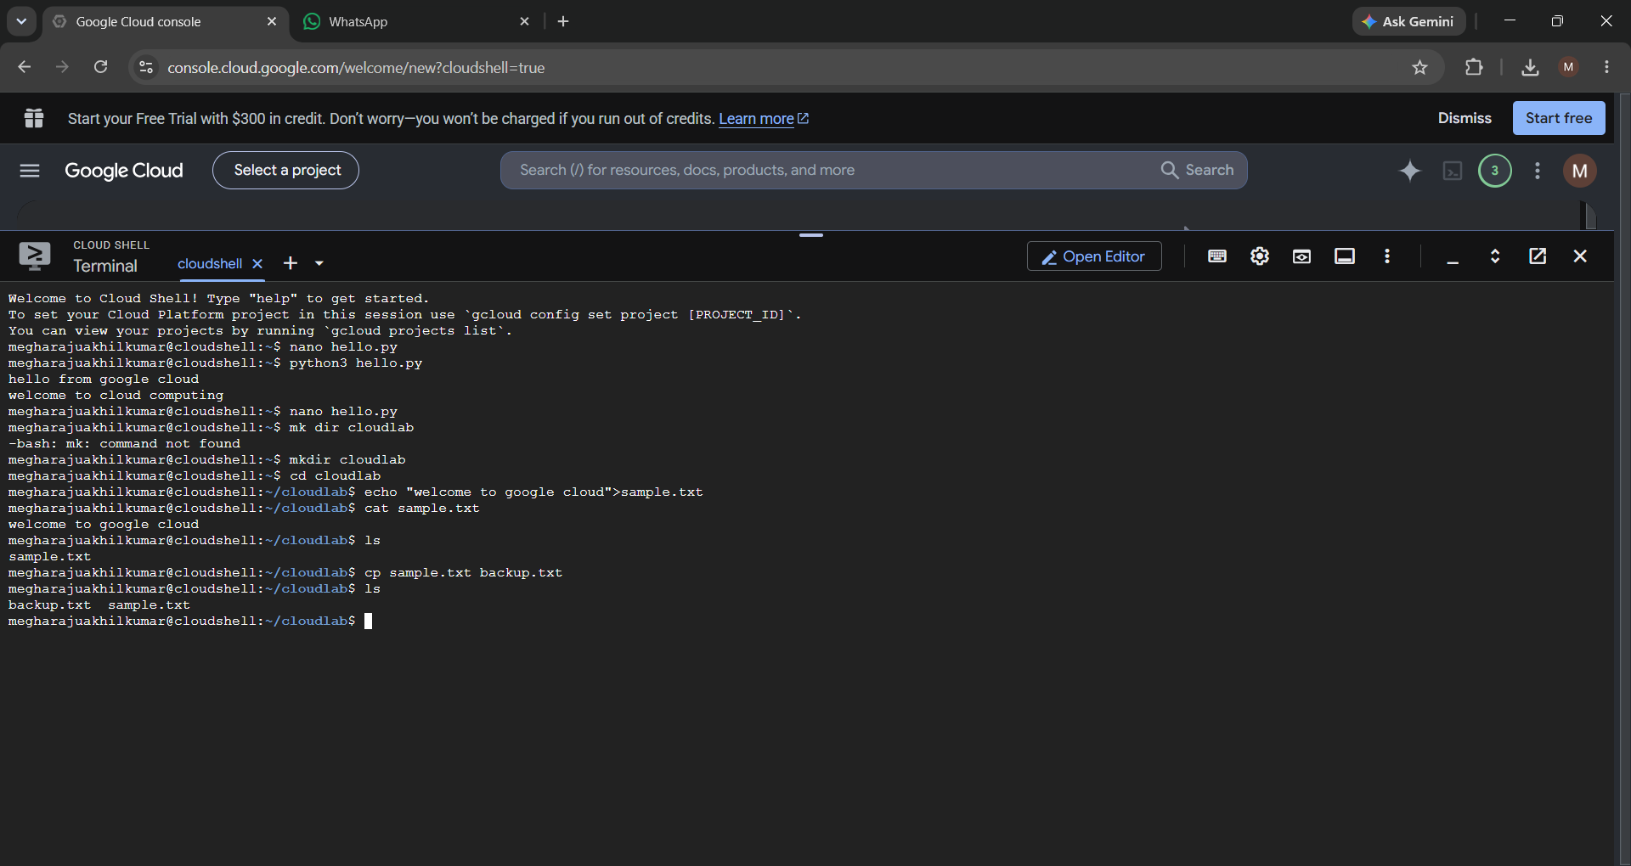
PYTHON CODING
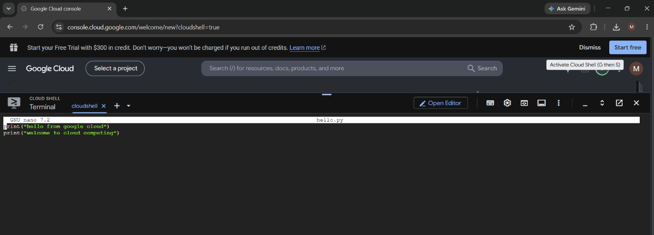
EXECUTE & OUTPUT

1b. Addition of two numbers using python in Google Cloud Shell
PYTHON CODING
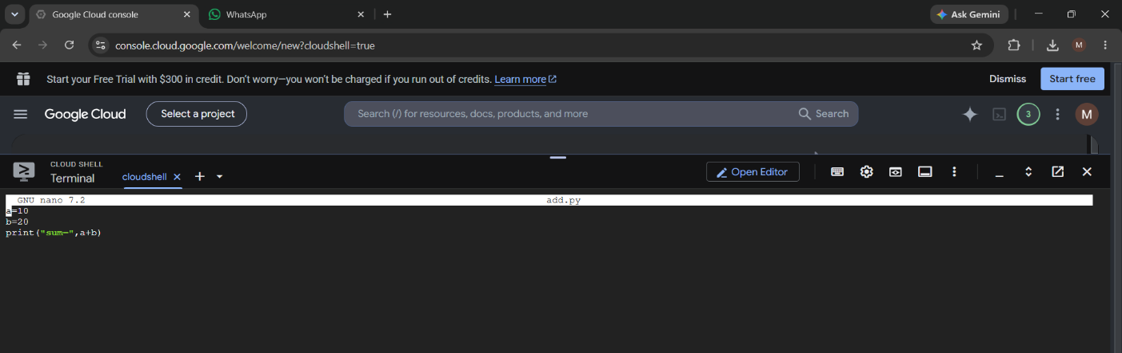

EXECUTE & OUTPUT
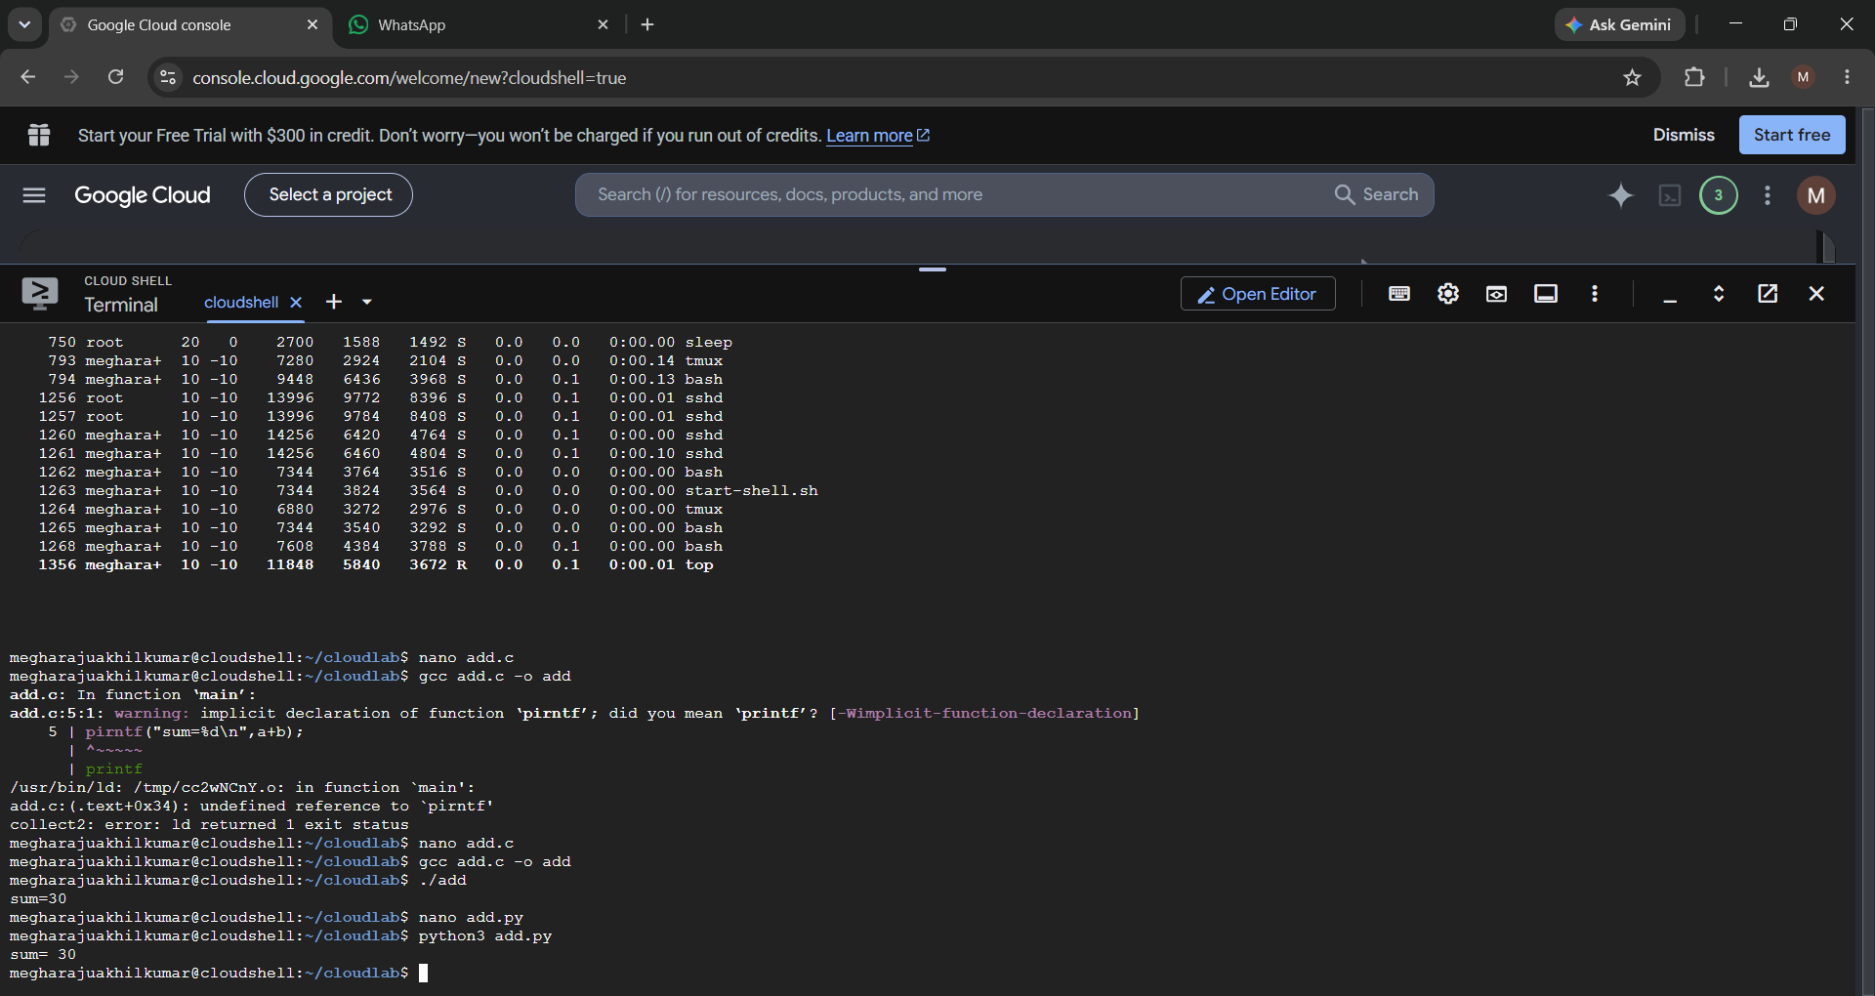

2. Create and Manage Files in Cloud Storage of Cloud Shell
Aim: Demonstrate cloud-based file creation and management.
EXECUTION OF ALL COMMANDS AND OUTPUTS
3. Run a Simple Web Server in Google Cloud Shell
Aim: Host and access a simple webpage from a cloud development environment.
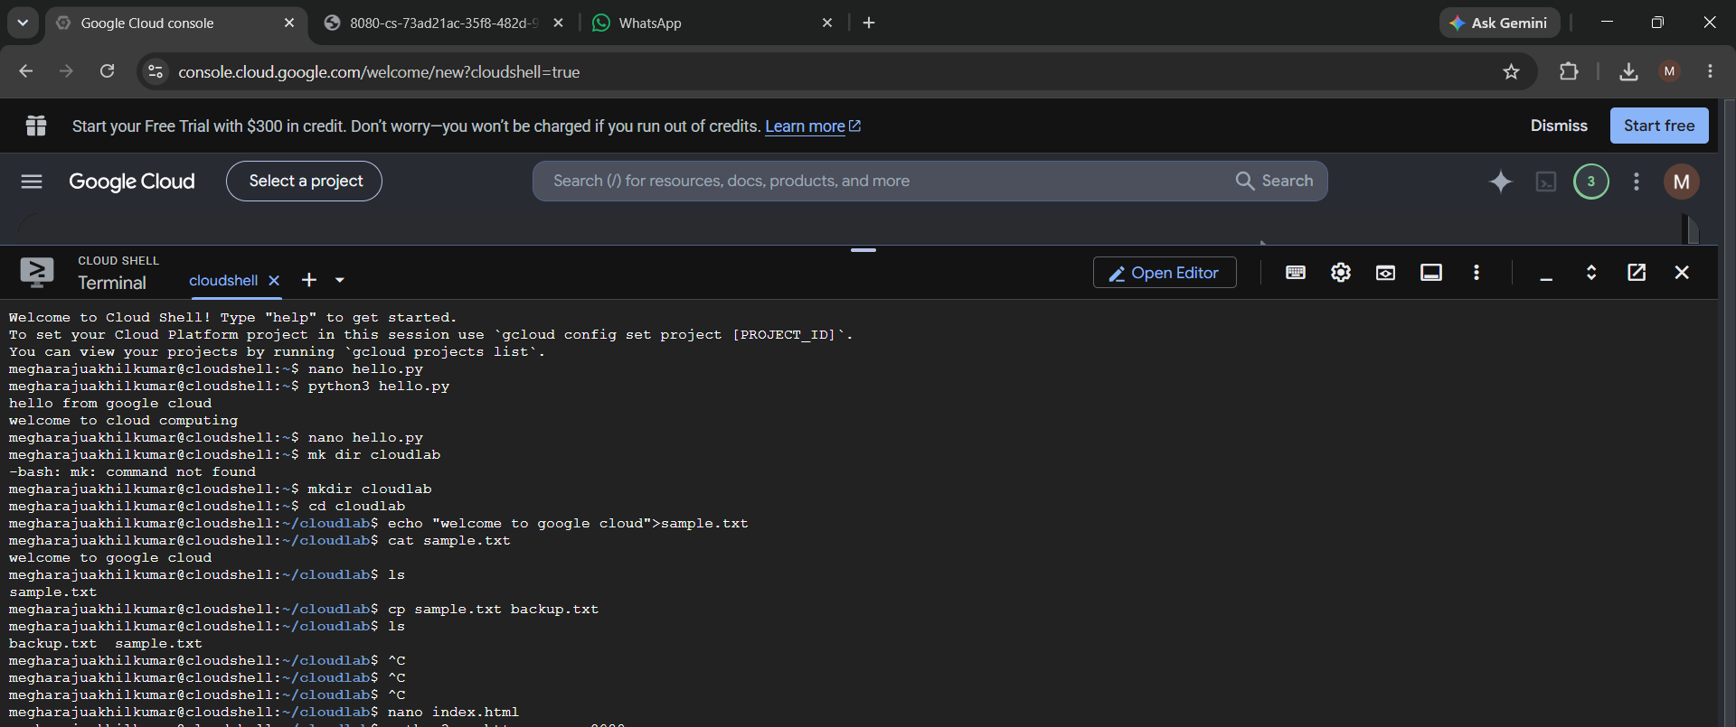
nano index.html
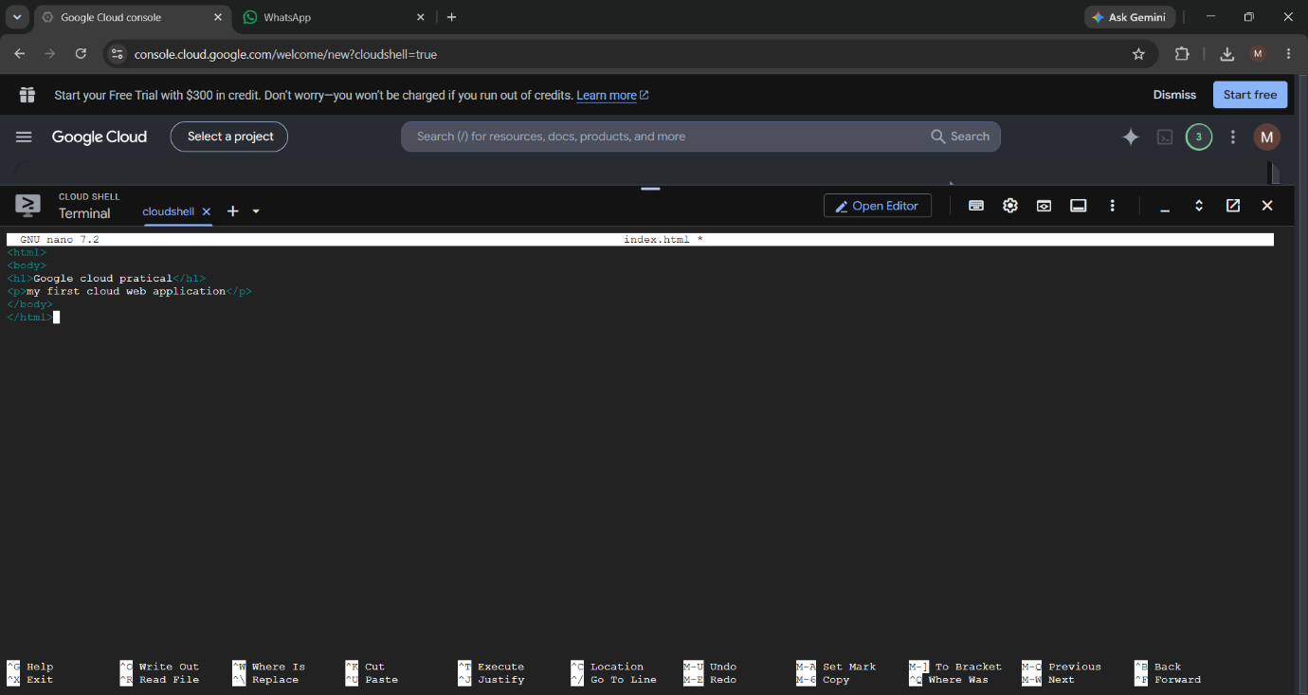
HTML CODE

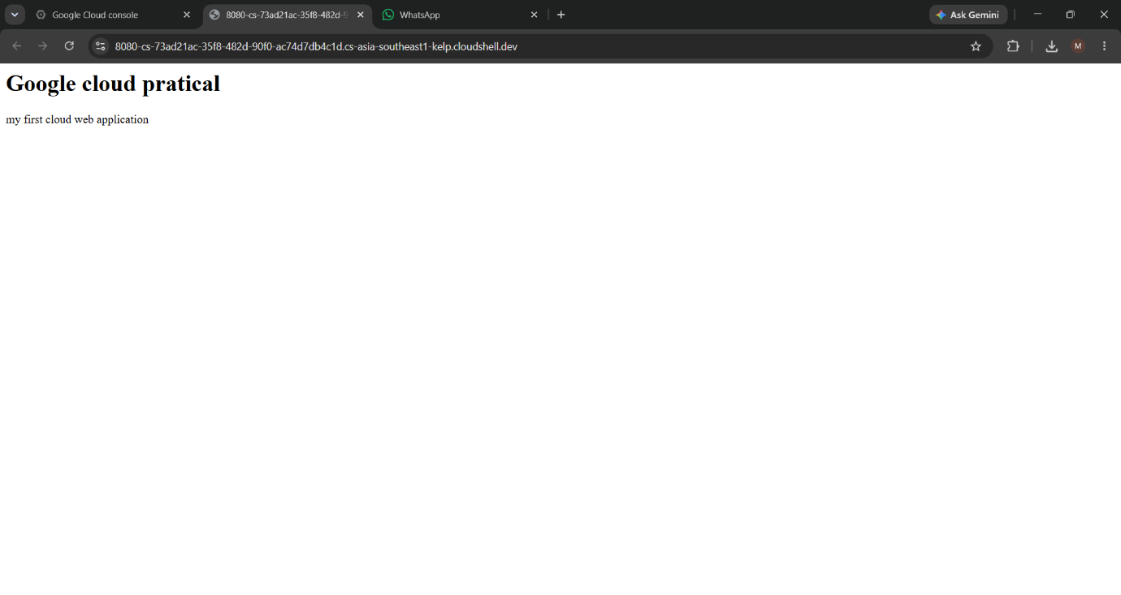
WEB OUTPUT

4. System Resource Monitoring in Google Cloud Shell
Aim: Demonstrate monitoring of CPU, memory and storage resources in a cloud environment.
ALL EXECUTIONS AND OUTPUTS
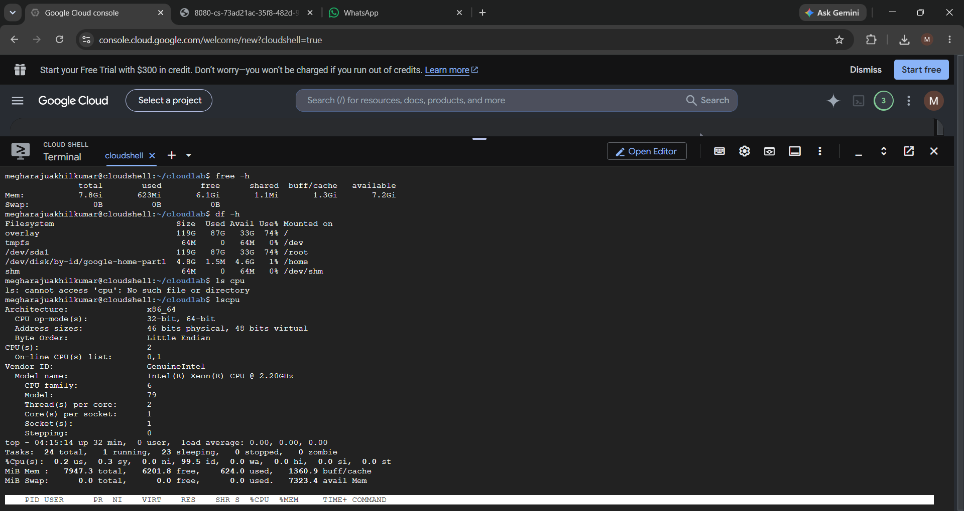

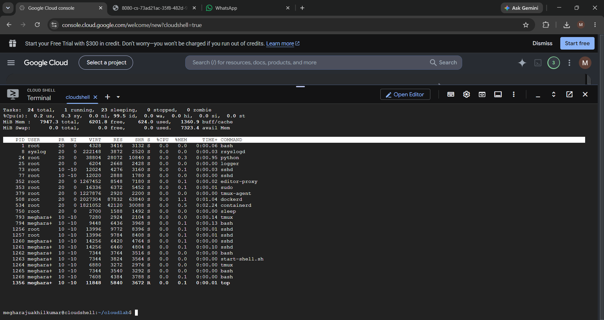

5. Execute a C Program in Google Cloud Shell
Aim: Compile and execute a C application in a cloud-based environment.
Create program:
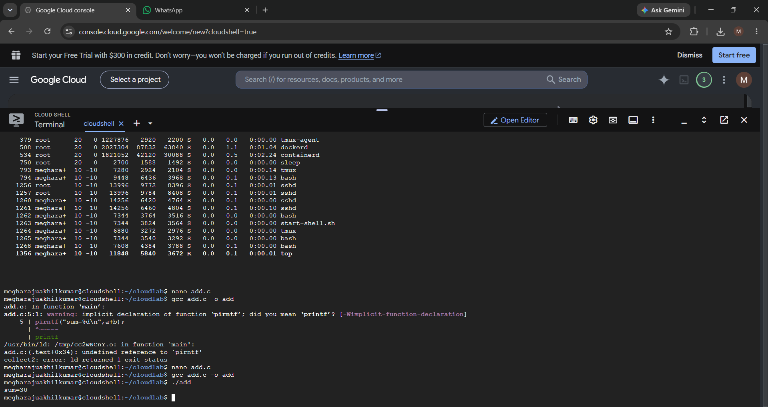
nano add.c

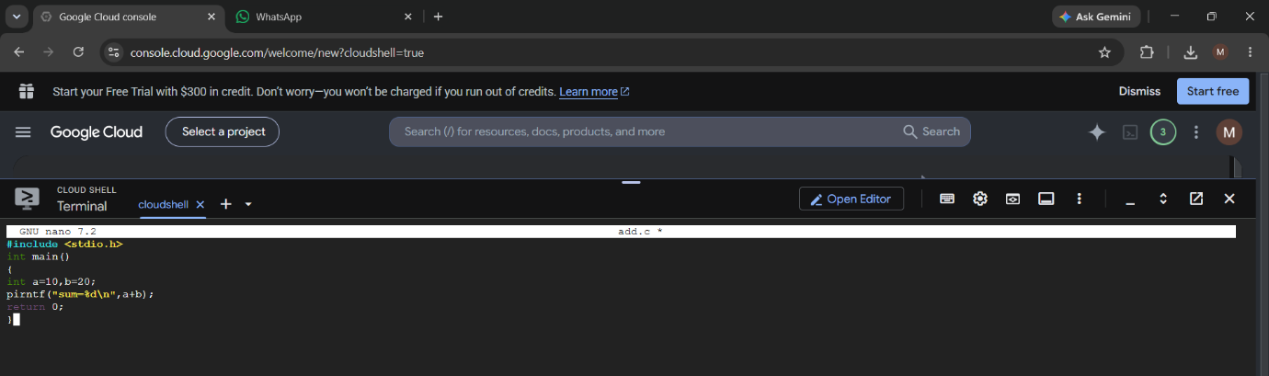
C PROGRAM CODE
OUTPUT

